May 15, 2023

EA Membership Communication,
Please join the Engineering Association (EA) Executive Committee in thanking Mike Cavote for his tireless efforts assisting members and growing the EA during his term as the EA Valley-Wide President. We wish Mike the best in pursuing his new personal endeavors.
Per our EA Bylaws, I, Carolyn Wilson, have assumed the office of Valley-Wide President. With this change in role, Anthony Chorney (previously the Southern Section President) has assumed the office of Valley-Wide Vice President. Both changes are effective immediately.
I have been employed with the Tennessee Valley Authority (TVA) for nearly 40 years with approximately 30 of those serving the EA in various capacities. I currently work as a Project Control Specialist (PCS) for Resource Management and Operations Services in Land Transactions with a history of PCS work in Nuclear and Transmission.
Anthony Chorney has been employed with TVA for nearly 21 years with approximately 9 of those serving the EA. He is currently a Senior Maintenance Specialist at the Browns Ferry Nuclear Plant. In 2002, he started his career at TVA as a General Building Mechanic at the Hartsville Distribution Center before moving back to Browns Ferry where he is a valued member of the Work Control Department.
We are both proud to serve as officers of the EA and will continue to support the interests of EA Employees at TVA!

In solidarity,

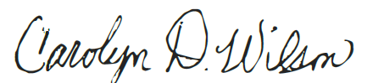

Carolyn D Wilson – EA Valley Wide President

